**DevOps project creation with code pull from github**

1. Upload the “docker support” enabled web app to the github repository.

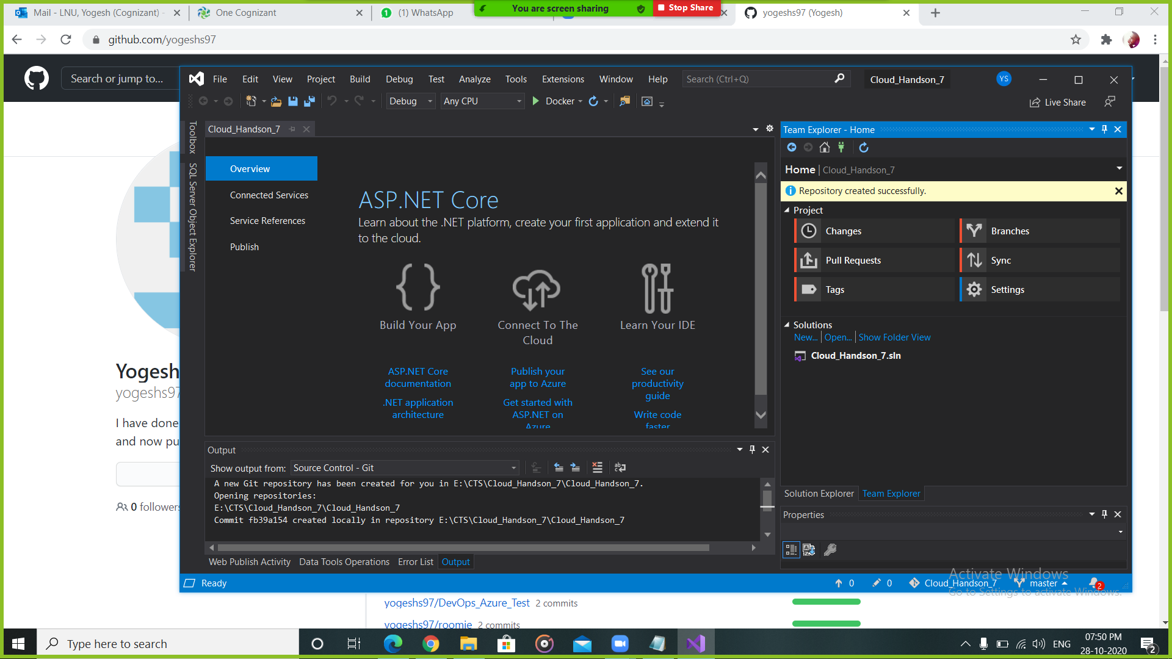

1. In azure, Create devops starter and select “bring your own code”.

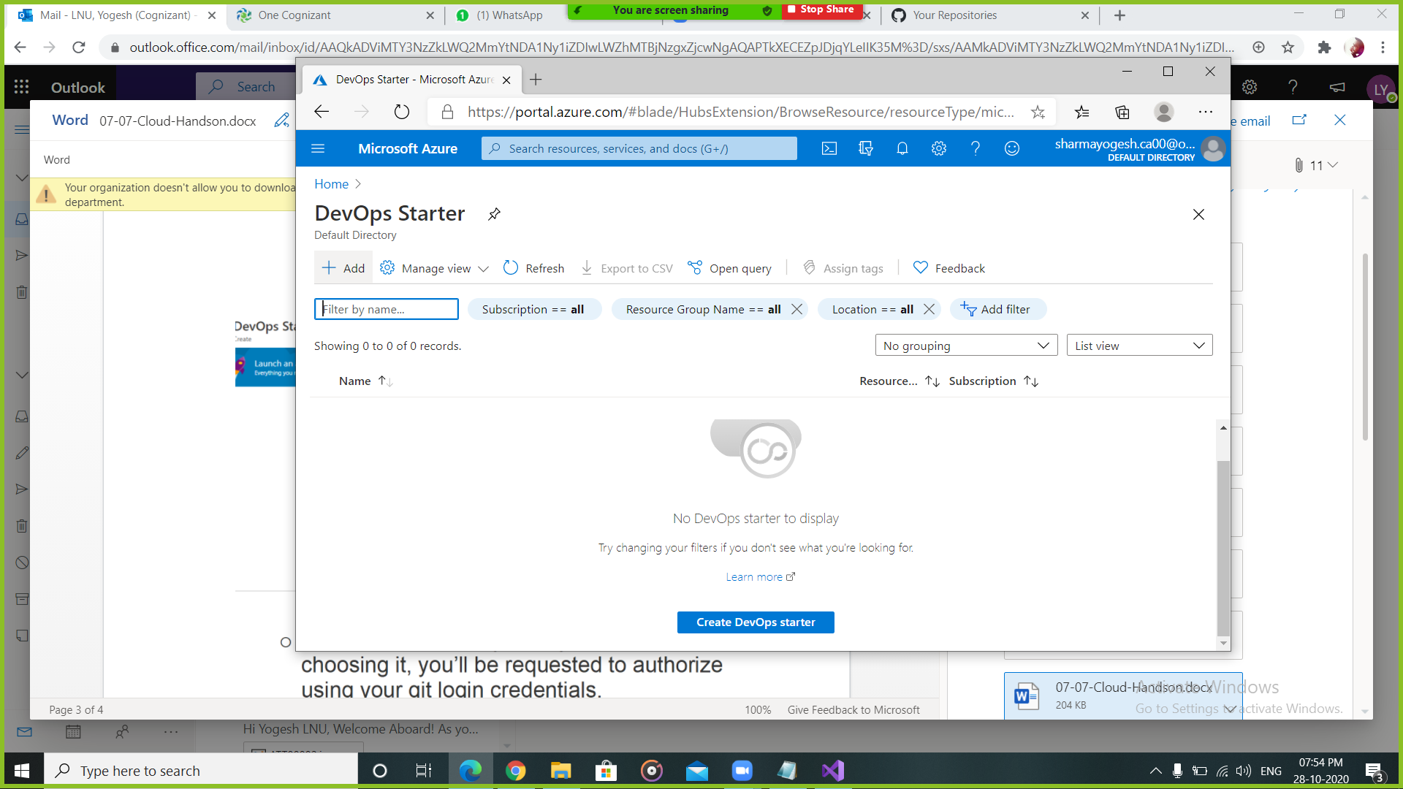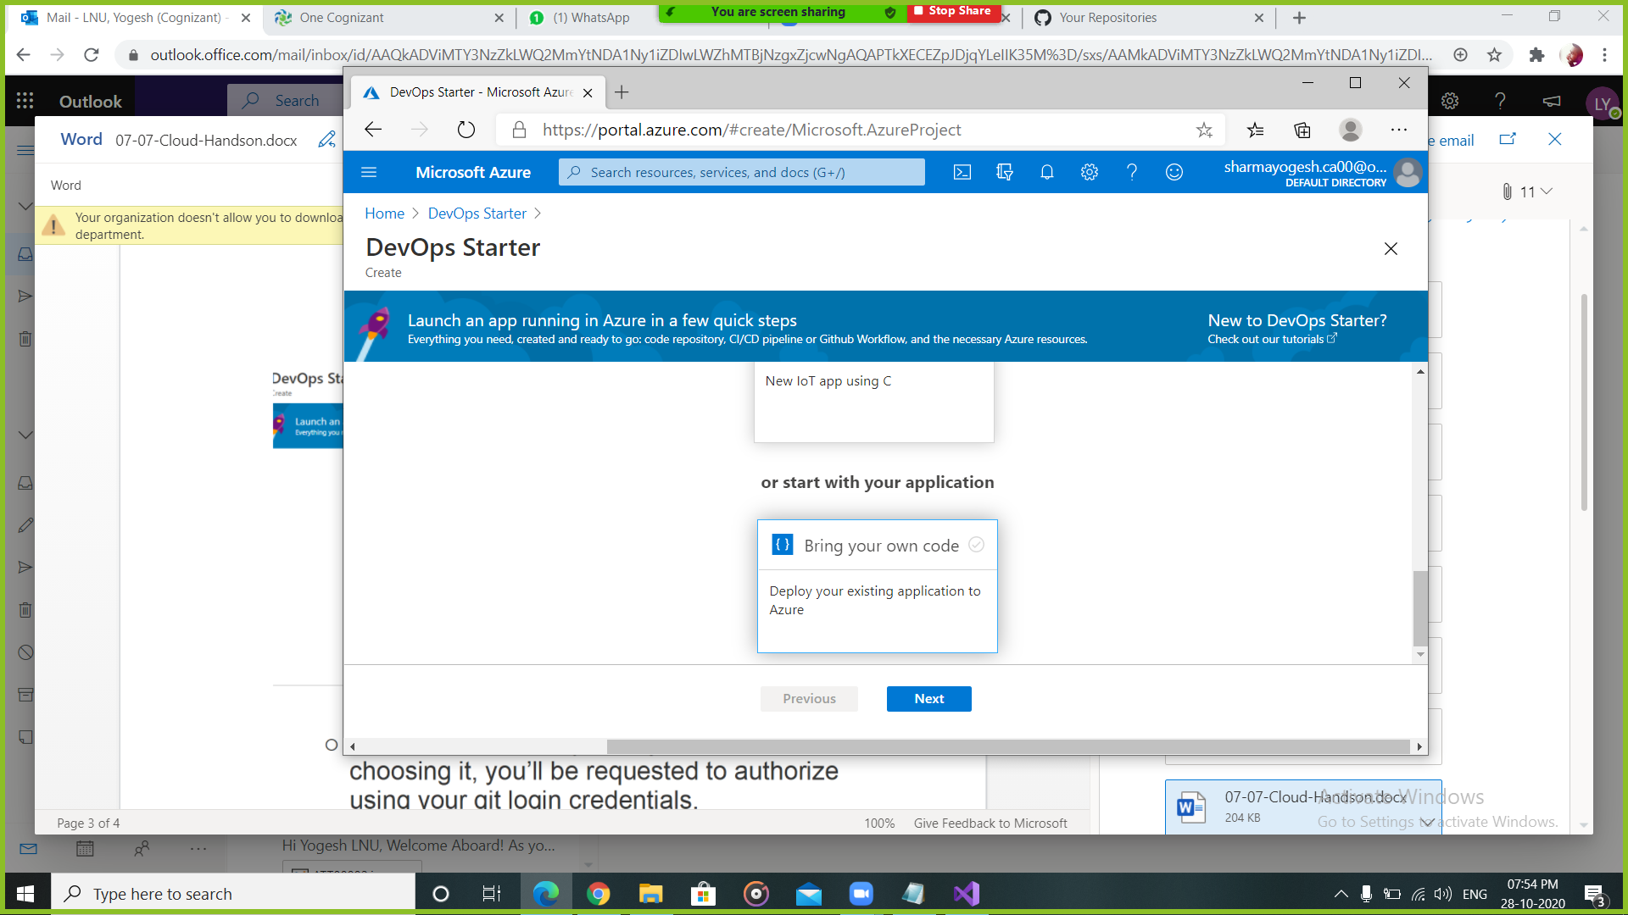

1. Choose the desired option and create. After the deployment, go to resource.

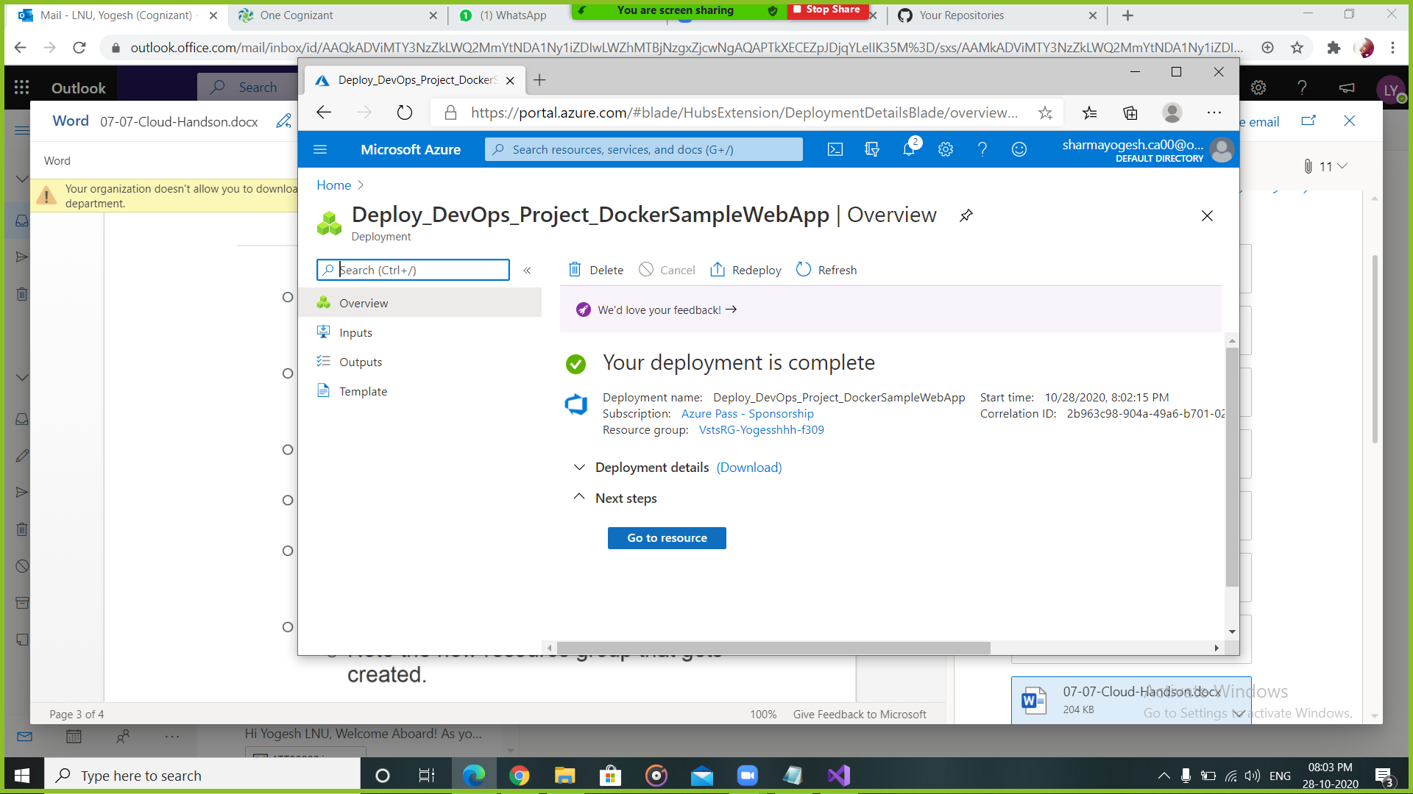

1. After the final release succeed, we can go to browse.

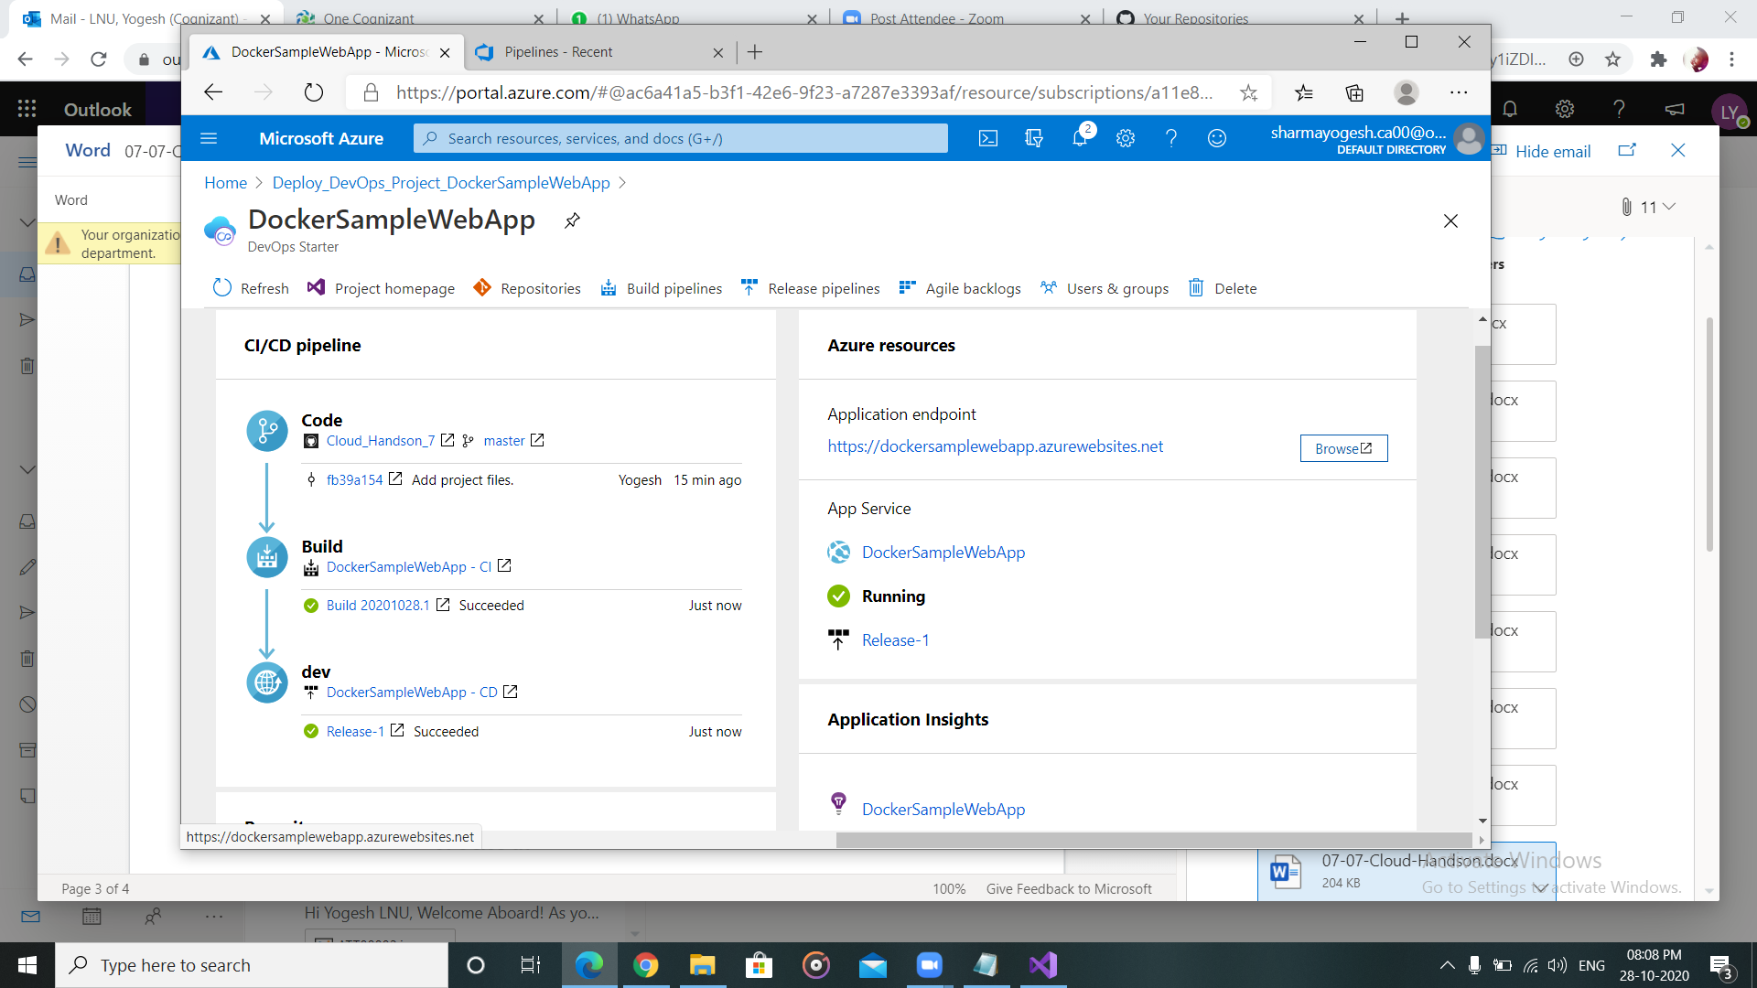

1. Add the controller name after the link in the url. And the controller will run.

